1. Membuat tampilan OS IOS (Cupertino Design)

import 'package:flutter/cupertino.dart';

void main() {

runApp(const MyApp());

}

class MyApp extends StatelessWidget {

const MyApp({Key? key}) : super(key: key);

// This widget is the root of your application.

@override

Widget build(BuildContext context) {

const themeDark =

CupertinoThemeData.raw(Brightness.dark, null, null, null, null, null);

return const CupertinoApp(

debugShowCheckedModeBanner: false,

title: "Flutter CupertinoApp",

theme: themeDark,

home: MyHomePage(title: 'CupertinoApp'),

);

}

}

class MyHomePage extends StatefulWidget {

const MyHomePage({Key? key, required this.title}) : super(key: key);

final String title;

@override

State<MyHomePage> createState() => _MyHomePageState();

}

class _MyHomePageState extends State<MyHomePage> {

@override

Widget build(BuildContext context) {

return CupertinoPageScaffold(

navigationBar: CupertinoNavigationBar(

middle: Text(widget.title),

),

child: const Center(

child: Text("This is CupertinoApp"),

),

);

}

}

Output :

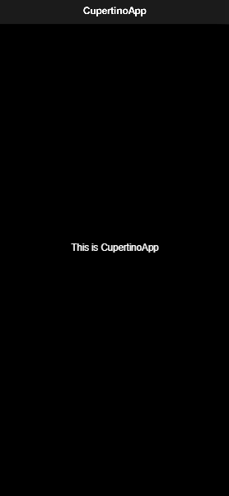

Penjelasan :

Disini saya membedakan folder project flutternya. Untuk membuat tema dark pada CupertinoApp ini saya menggunakan CupertinoThemeData.raw. Pada CupertinoApp menggunakan NavigationBar yang fungsinya sama seperti AppBar pada MaterialApp. Saya menambahkan debugShowCheckedModeBanner : false, yang fungsinya untuk menghilangkan tulisan Debug di pojok kanan atas saat di run.